User
Manual Book
Kitchen Sink

KS 9110F

INSTALLATION INSTRUCTION
Topmount Sink

- Place the sink upside down in the position where it will be installed; and draw the line with a pencil around the sink to make sink outline on the countertop.

- Move the sink out of the countertop and draw another line with inner spacing 10 mm (1 cm) from the first line. Drill all four corners with a hole and cut along the countertop following the second line (another option is to use the “cut-out” dimension that provided through the label attached on the product).

- Adhere the waterproof seal tape around the underside of the edge of the sink. Lay the sink slowly (without ridges on its seal).

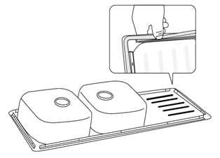

- Install the anchor bracket vertically underside the sink and pull it up to lock the sink into horizontal position.

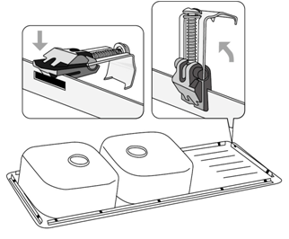

- These anchor brackets are designed to be used for countertop with thickness 30 - 40 mm (1). If the countertop is thinner, insert the wooden wedges between the countertop and the brackets to secure them (2). After installing two brackets at each corner, install the rest evenly spaced around the perimeter of the sink.

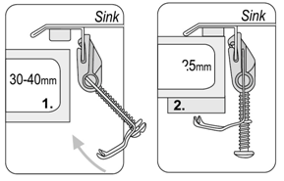
5 mm

30-40mm
Sink

Sink

- Tighten the screws of the anchor brackets to secure the sink in its place.

Undermount Sink

- Place the cut-out template on the desired sink location. Then, draw line around cut-out template to make the sink outline.
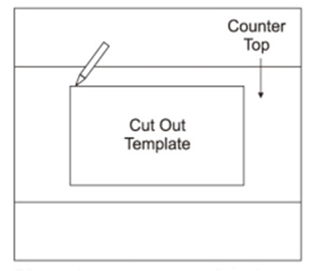
Countertop
Cur-out
Template

- Move out the template; cut along the countertop based on the made line using appropriate cutting tool.
NOTE
Make sure that the dimension of the cut-out line corresponds to the dimension of the sink before cutting.

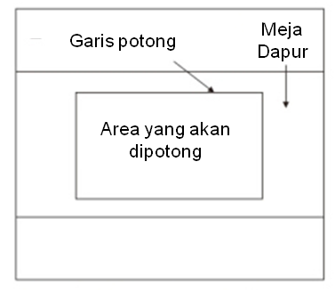
Countertop
Area to be
Cut-out
Cut-out Line
- Drill the underside of the countertop as shown in the picture below.
45 mm
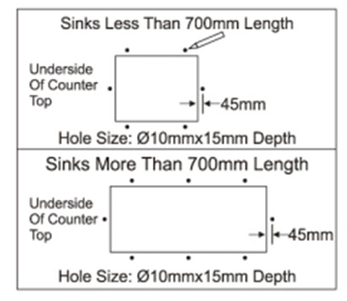
Hole Size ∅10mm x 15mm Depth
Hole Size ∅10mm x 15mm Depth
Sink Less than 700 mm Length
45 mm
Underside of
Countertop
Underside of
Countertop
Sink More than 700 mm Length

- Insert the Fischer screw anchors into the drilled holes.

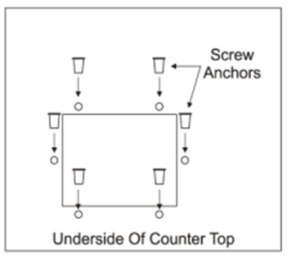
Screw Anchors
Underside of Countertop

- Place the fixing brackets over the screw anchors; insert the provided screw, but do not fully tighten it.
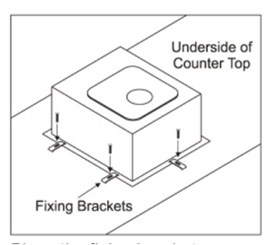
Fixing
Brackets
Underside of Countertop

- Check the alignment between the kitchen sink and the cut-out hole.
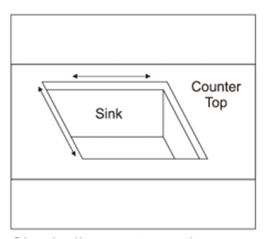
Counter-
top
Sink

- Apply sealant to the suitable wet area that recommended for stainless steel sink and countertop material.
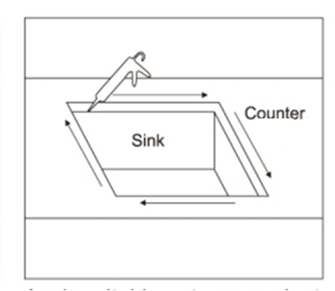
Counter-
top
Sink

- Tighten the screws carefully if the sink is already in the desired position, dan remove the leftover sealant around the sink.
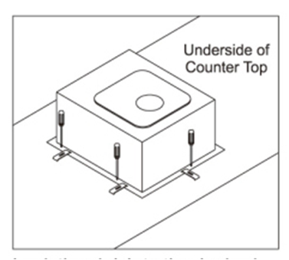
Underside of Countertop
PRODUCT DIMENSION

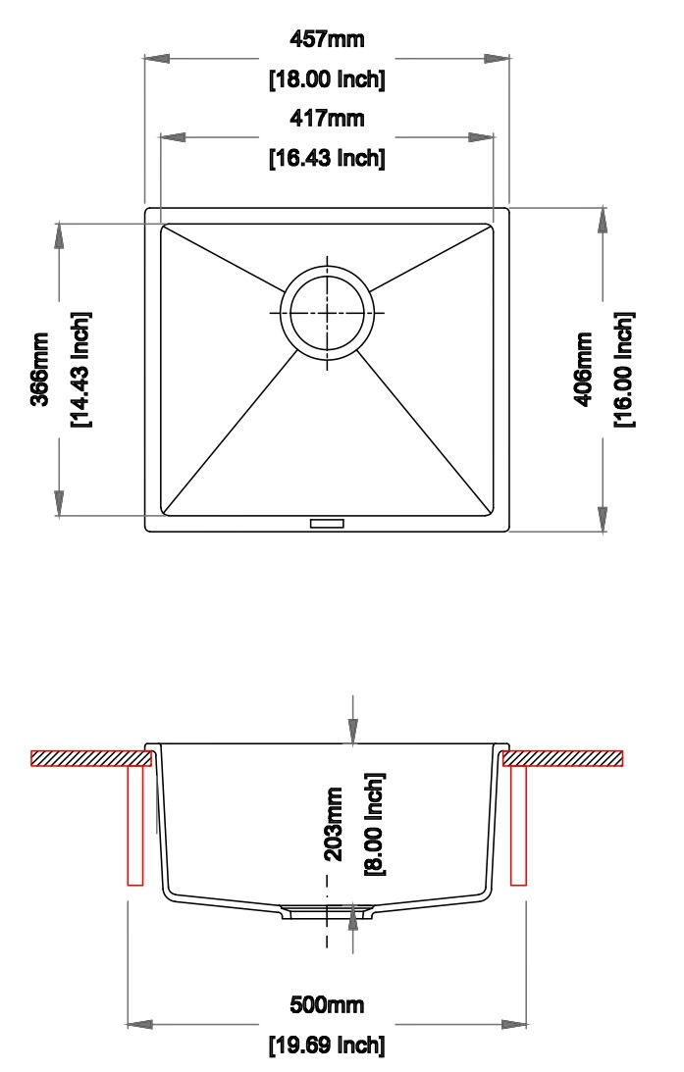
CUT-OUT DIMENSION

